Video Link
https://youtu.be/VTZi0s5-NSs

Fragments GitHub
https://github.com/MansoorAZafar/fragments

Fragments-UI GitHub:
https://github.com/MansoorAZafar/fragments-ui

AWS ECS Hosted Service URL:
http://fragments-lb-991467440.us-east-1.elb.amazonaws.com

Successful GitHub actions CI Workflow
https://github.com/MansoorAZafar/fragments/actions/runs/14419040048
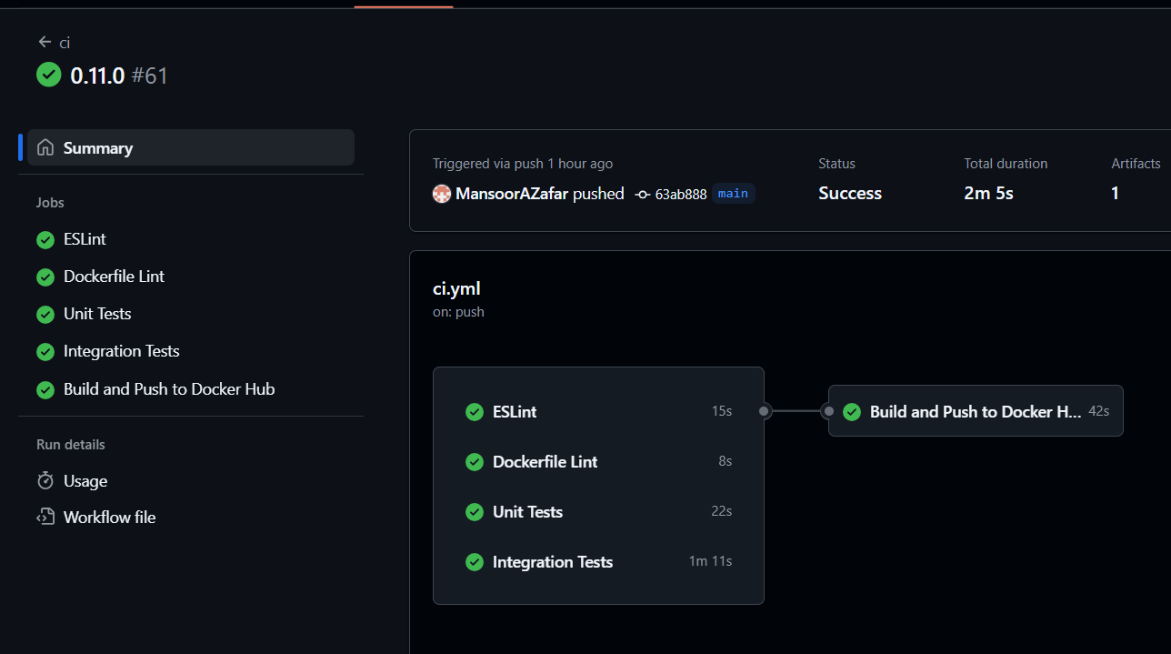
Successful GitHub actions CD Workflow
https://github.com/MansoorAZafar/fragments/actions/runs/14419040030
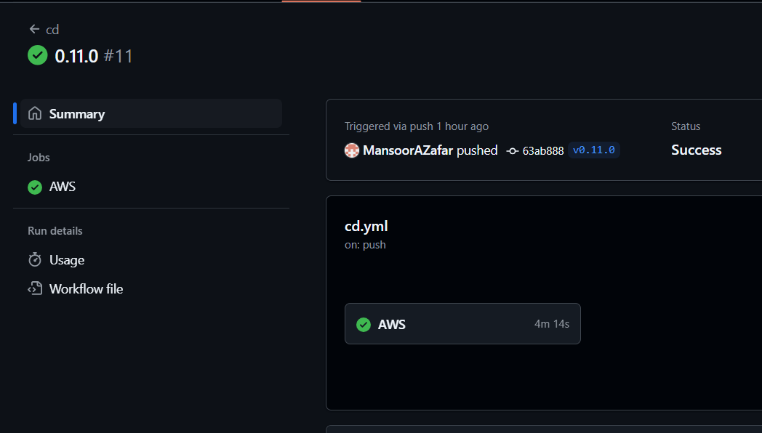
ECR with newest version (0.11.0)
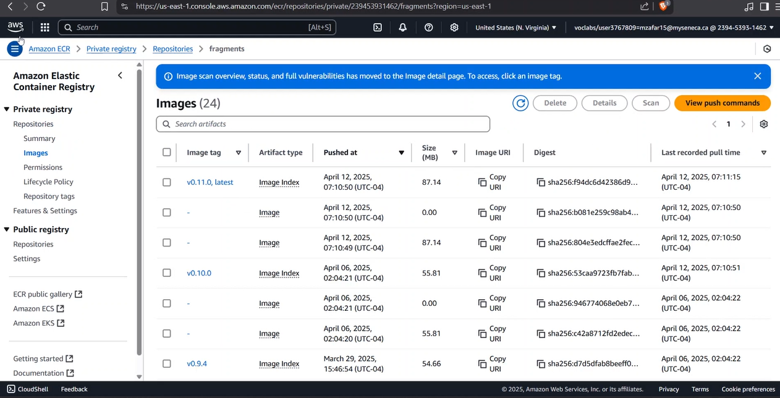

NPM Coverage:
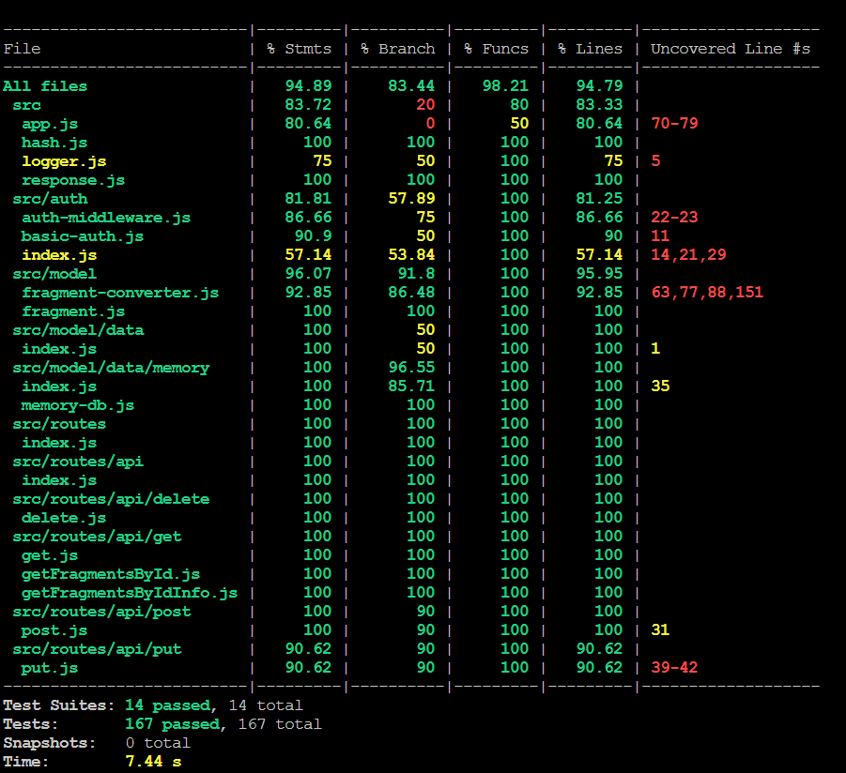

List of deficiencies:
What’s left of what I could have done is just some more tests, like adding more tests for the Conversions by testing more of the smaller helper functions or even testing the logger to ensure it prints out right output. Also, adding the functionality of being able to see the images in the frontend rather than their ‘textual’ binary data which is not readable.

